|  |
| --- |
|  |
| 新概念 3 册 |
| Lesson7 Mutilated ladies |

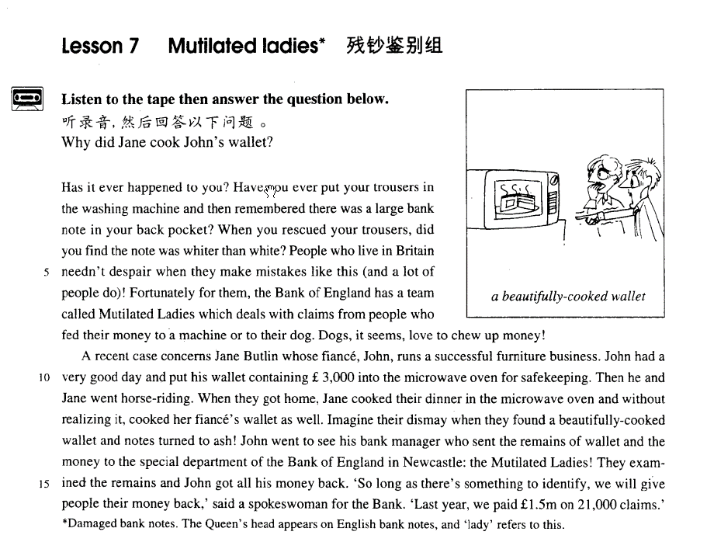

## 课文

Has it ever happened to you?

这种事情在你身上出现过吗?

Have you ever put your trousers in the washing machine and then remembered there was a large bank note in your back pocket?

你有没有把裤子塞洗衣机，然后又想在裤子的后兜有一张大面值的纸币?

When you rescued your trousers, did you find the note was whiter than white?

当你把裤子抢救出来时，你有没有发现那张纸币已经变得比白纸还白?

People who live in Britain needn't despair when they make mistakes like this (and a lot of people do)!

当英国人犯这种错误时，他们不必感到绝望（而许多国家的人都有这种绝望的感觉）。

Fortunately for them, the Bank of England has a team called Mutilated Ladies which deals with claims from people who fed their money to a machine or to their dog.

对英国人来说，值得庆幸的是英国银行有一个残钞鉴别组，负责理那些把钱塞进机器或塞给狗的人提出的索赔要求。

Dogs, it seems, love to chew up money!

看起来，狗很喜欢咀嚼钱币。

A recent case concerns Jane Butlin whose fiance, John, runs a successful furniture business.

最近的一个案例与简.巴特林有关，她的未婚夫约翰拥有一家生意兴隆家具店。

John had a very good day and put his wallet containing ￡3000 into the microwave oven for safekeeping.

有一天约翰的生意很好，他把一只装有3,000 英镑的钱包放进微波炉内保存。

Then he and Jane went horse-riding.

然后，他和简一起去骑马。

When they got home, Jane cooked their dinner in the microwave oven and without realizing it, cooked her fiance's wallet as well.

回家后，简用微波炉煮了晚饭，无意中之中把她未婚夫的钱包也一起煮了。

Imagine their dismay when they found a beautifully-cooked wallet and notes turned to ash!

可以想像他们发现一只煮得很好看的钱包，钞票已化成灰时的沮丧心情。

John went to see his bank manager who sent the remains of wallet and the money to the special department of the Bank of England in Newcastle: the Mutilated Ladies!

约翰去找银行经理，经理把约翰的钱包和纸币的残留物送到英国银行在纽卡斯尔的一个专门部门--残钞鉴别组。

They examined the remains and John got all his money back.

他们鉴定了这些残留物。约翰拿回了他损失的全部数额。

‘So long as there’s something to identify, we will give people their money back,' said a spokeswoman for the Bank.

“只要有东西可供识别，我们会把钱还给人家的，”银行的一位女发言人说。

‘Last year, we paid ￡1.5 million on 21,000 claims.’

“去年，我们对21，000 起索赔要求支付了150万英镑。”

词汇讲解

* **mutilate ['mju:tɪleɪt]** v. 使残缺不全
* He was mutilated in a car accident and lost one arm. The painting has been **mutilated** by a boy.

**maim *vt.*** 使残废

* One man has lost his life; another has been **maimed**.

**paralyze *vt.*** 使麻痹；使瘫痪

* The accident left him paralyzed from the waist down.

**cripple** ***n.*** 跛子；残废； ***vt.*** 削弱；使跛；使残废 ***adj.*** 跛的；残废的

**disable *vt.*** 使失去能力；使残废；使无资格

the disabled 残疾人

the handicapped 残疾人

the physically challenged 委婉表达“残疾”

the mentally challenged 委婉表达“弱智”

the horizontally challenged 委婉表达“肥胖”

the vertically challenged 委婉表达“侏儒”

* **chew** [tʃu:]

v. 咀嚼

* 托福**听力：**

A. He spilled it on the table.

B. You have an aspirin, don't you?

C. You can sit on the pillow.

D. Swallow this tablet.

对话：

Here, take this pill, and don’t chew it. Answer:

答案：

(D) Swallow this tablet.

**bite** ***v.*** 咬；

bite off more than one can chew 试图做超出能力的事

**swallow *vt.*** 忍受；吞没 ***vi.*** 吞下；咽下

**gobble *vt.*** 狼吞虎咽

**devour *v.*** 吞食；毁灭

* Only two stray dogs benefited from all this confusion, for they greedily **devoured** what was left of the cake.

**nibble *v.*** 细咬；一点一点地咬；吹毛求疵

* Eagles catch snakes that **gobble** toads that swallow insects that nibble green leaves.
* **fiancé** [fɪ'ɑ:nseɪ] n. 未婚夫

**fiancée *n.*** （法）未婚妻

**husband-to-be** 未婚夫 准丈夫

**bride-to-be** ***n.*** 待嫁新娘

**groom / bridegroom** ***n.*** 新郎

**bride** ***n.*** 新娘；

**bridesmaid maid of honor** ***n.*** 伴娘

**groomsman best man** ***n.*** 伴郎

**newlyweds happy couple *n.*** 新婚夫妇；

* Armed with the right tools and materials, **newlyweds** gaily embark on the task of decorating their own homes.
* **oven** ['ʌvn] n. 炉灶（没有明火）

microwave oven 微波炉

Michael Owen 发音相似

**stove *n.*** 火炉

**gas cooker *n.*** 瓦斯炉

**fireplace *n.*** 壁炉

**furnace *n.*** 火炉，熔炉，锅炉

* **spokeswoman** ['spəuksˌwumən]n. 女发言人

spokeswoman

spokesman

spokesperson 政治正确的表达

chairman

chairwoman

chairperson 政治正确的表达

* 托福**听力：**

1. He thought Dr. Jeffries would get the job.
2. He's not sure Dr. Jeffries will be a good chairperson.
3. He doesn't know Dr. Jeffries very well.
4. He thought it took too long to make the decision.

对话：

W: The dean just announced that Dr. Jeffries is going to take over as **Chairperson** of the English Dept.

M: I knew it all along. He was the obvious choice.

答案：

What does the man mean?

Answer: (A) He thought Dr. Jeffries would get the job.

课文讲解

**dead presidents** 美钞

# Has it ever happened to you?

**happen to do** 碰巧发生，to做不定式

**sth. happen to sb.** to是介词，happen这里做“发生了”

= **come up** 可相互替换

* Has it ever **come up** to you?

**sth. occur to sb.** 某人想到了某事

* A car accident **happened to** him. 发生到他身上
* A good idea **occurred to** me. 我想到了一个好主意

# Have you ever put your trousers in the washing machine and then remembered there was a large bank note in your back pocket?

**remember / recall / recollect sth.** 回忆起某个事情

**remind sb. of sth.** 使某人回忆起某事

* We can perhaps forgive those who said the moons of Jupiter were produced by Galileo's spyglass if we **recall that** in his day, as for centuries before, curved glass was the popular contrivance for producing not truth but illusion, untruth; and if a single curved glass would distort nature, how much more would a pair of them?
* She could no longer **recollect** the details of the letter.
* As its composition and line **reminded him of** an Italian painting he knew well, he decided to buy it.

**bank note / banknote / note** 纸钞 （英）

**bill** 美钞 （美）

**a fake / counterfeit** $20 bill 假钞

**Bill / William**

* Bill Clinton
* Bill Gates

**coin** 硬币

**change** 零钱（不可数）

bill note coin 可数

* I carry no **change** on me.

# When you rescued your trousers, did you find the note was whiter than white?

**rescue / save** “救人/物“

* When a passing tanker **rescued** them five days later, both men were genuinely sorry that they had to leave.
* Vince is a fireman. Wow! Have you ever **rescued** anyone **from** a burning building before?

**come / go to one’s rescue** 来/去救某人

* When John was in trouble, everyone went to his rescue.

**pick up sb.** 救起某人，尤其只用飞机、轮船救上来

* The 'Antoinette' floated on the water until Latham was picked up by a ship.

**salvage ... from ...** 只能是就事物，不能是救人

* He tried desperately to **salvage** belongings **from** the burning house.
* The captain of the Elkor ordered his men to **salvage** as much as possible **from** the wreck.

**savior / saviour** ***n.*** 救世主；救星；救助者

**a knight in shining armor** 穿着闪亮盔甲的骑士

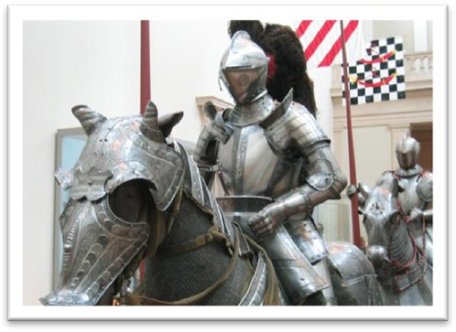

* I don't know who you are, Nick. You just magically show up like some **knight in shining armor**, ready to save the day （力挽狂澜）...

# People who live in Britain needn't despair *when they make mistakes like this* (and a lot of people do)!

**口音重要的发音现象：鼻腔爆破 （nasal explosion）**

[t] / [d] + [n]

Britain mutton certain

mountain didn’t student

**despair of sb.** 对某人绝望

**despair of (doing) sth.** 对某（做）某事绝望

* The teachers began to **despair of him**.
* Mike **despaired of** ever seeing her again.

**in despair** 绝望地的做某事，做状语

* He killed himself **in despair.**
* I gave up **in despair**.
* I got up early next morning hoping to find that the ants had given up **in despair.**
* With this faith, we will be able to hew out of **the mountain of despair** a stone of hope.

“and a lot of people do” do后面省略：

... and a lot of people despair when they make mistakes like this.

# Fortunately for them（状语）, the Bank of England has a team（句子主干） called（过去词短语作后置定语修饰team） Mutilated Ladies *which deals with claims from people who fed their money to a machine or to their dog（定语从句修饰people）*.

**deal with ... *na.*** 办理；对待；与…交涉；与…交易，既可指处理具体事情，也可指处理或解决具有抽象意义的问题。

* **四级听力：**

1. She made a mistake by taking too few courses in the first term.
2. The courses she took were too difficult for her.
3. She took too many courses during her first term.
4. She found it difficult to deal with college courses.

对话：

W: I had to deal with so many courses last term that I really had a hard time.

M: I told you it would be better for you if you took fewer courses during the first semester.

问题：

Q: What do we learn about the woman?

答案：

Answer: (C) She took too many courses during her first term.

**attend to ... *na.*** 照料(工作) 照顾；注意；处理

* You hang up hurriedly and attend to baby, crockery, etc.

**see to ... *na.*** 注意；留心；当心；检查

* Don’t worry about it. I’ll **see to** it later.

**handle ... *vt.*** 处理

* Molly, I need your special talent for **handling** special matters.

**tackle** … ***vt.*** 处理

* Many schools are now trying to **tackle** the problem of drug abuse.

**cope with ... *v.*** 对付；应付 处理；应对；解决

* a seminar on ‘**coping with** stress in the workplace’

**feed sth. to sb.**  把某物喂给某人

**feed sb. on sth.** 把某物喂给某人

* I **fed raw meat to the dog**.
* I **fed the dog on raw meat**.

**Well-fed, well-bred.**

* She **fed two** coins into the machine for a cup of coffee. 投币

**语法：zeugma 轭式修辞**

**一个动词与多个名词搭配，表示不同的含义。**

* Clothes that ***fit***the man and the times. 既合体又时尚
* You’re free to *execute* your laws, and your citizens, as you see fit.

# Dogs, it seems, love to chew up money!

正常一般语气：

It seems that dogs love to chew up money.

课文原文结合上下文，突出主次Dogs，it seems 降为插入语

* Why, you may wonder（插入语）, should spiders be our friends? You may wonder why spiders are our friends.

突出主次对比

* Many of us believe that economic development is of paramount importance to China.
* Economic development, **many of us believe**, is of paramount importance to China.

# A recent case concerns Jane Butlin whose fiance, John, runs a successful furniture business.

**concern ...** 有关于，（更正式，更适合书面语）

**be about ...** 有关于

* A recent case **is about** Jane Butlin …
* To whom it may **concern**,
* One case **concerns** an eleven-year-old schoolgirl, Vera Petrova, who has normal vision but who can also perceive things with different parts of her skin, and through solid walls.
* **造句：**最近一则新闻是有关于罗京, 中央电视台的一位著名播音员(newscaster), 因癌症而去世。
* A recent piece of news concerns Luo Jing, a popular CCTV newscaster, who died of cancer.

主动被动都表“与…相关”

**concern** …

**be concerned with …**

* The book **concerns** music.
* The book **is concerned** with music.
* a book **concerning** music （做介词）
* a book **concerned with** music

**run**: be in charge of (sth); 经营，管理

**manage** 经营，管理

* run a hotel / shop / language school 经营学校/商店/学校

John manages a successful furniture business.

John is in charge of a successful furniture business.

# John had a very good day and put his wallet *containing￡3,000* into the microwave oven for safekeeping.

# Then he and Jane went horse-riding.

去做某事：

go fishing

go hunting

go camping

go bowling

go sight-seeing

go mountain-hiking

# When they got home, Jane cooked their dinner in the microwave oven and *without realizing it*, cooked her fiancé's wallet as well.

介词短语引导原因状语：

... without knowing it, ...

... without being aware of it ...

# Imagine their dismay when they found a beautifully-cooked wallet and notes turned to ash!

**dismay:** both shocked and discouraged 既震惊又沮丧

**表“变成”：**

**turn to / into ...**

**change into ...**

**become**

* The caterpillar eventually **turns to** / **into** changes into becomes a beautiful butterfly.

**turn 后面如果加名词做表语，只能加人的职务，身份，地位**

* The teacher turned writer.
* He has turned traitor.

**imagine one’s … when …** 想象一下当某个时候某人的某种表现

* **Imagine his** dismay **when** he found he took the wrong train.
* **Imagine** her exultation **when** she received the admission notice from Beijing University.

# John went to see his bank manager who sent the remains of wallet and the money to the special department of the Bank of England in Newcastle: the Mutilated Ladies!

**语法：continuative clause 接续性分句：**

**用定语从句代替其他句子有个条件，上面半句的末尾必须是下面半句句子中的一个成分，**定语从句有的时候是并列句，有的时候甚至是各种状语从句。

John went to see his bank manager and the manager sent the remains of wallet and the money to the special department of the Bank of England in Newcastle: the Mutilated Ladies!

* He violently beat the boy and the boy later died from his injuries.

——>He violently beat the boy who later died from his injuries.

* We can read of things that happened 5,000 years ago in the Near East, where people first learned to write.
* We can read of things that happened 5,000 years ago in the Near East, because people first learned to write there.
* Don’t sit on the chair because it has a broken leg.
* Don’t sit on the chair **which** has a broken leg.
* I have to be very careful not to offend the manager because he could give me the sack at any time.
* I have to be very careful not to offend the manager who could give me the sack at any time.
* History books never mention those people although they really helped civilization forward.
* History books never mention those people **who** really helped civilization forward.

# They examined the remains and John got all his money back.

# So long as there’s something to identify, we will give people their money back,' said a spokeswoman for the Bank. ‘Last year, we paid ￡1.5 million on 21,000 claims.‘

表“只要”引导条件状语从句

**as / so long as …**

**provided / providing (that) … 这两个可以直接当连词，不一定加that**

**on condition (that) …**

* You'll be quite safe **as long as** you follow my instructions.
* He can come with us, **provided / providing (that)** he pays for his own meals.
* I'll lend you the money **on condition (that)** you pay it back within three weeks.

**only if … 表“只有”引导**条件状语从句

* she will go only if he goes.
* Only if he goes *will* she go. （注意部分倒装）
* This can give rise to curious situations, as it did in the case of Alfred Bloggs who worked as a dustman **for** the Ellesmere Corporation. 公司前加for

突出说话内容，“某人说“放中间

* "I'm trying to repair the bell," **answered Bill.** " I've been coming up here night after night for weeks now. You see, I was hoping to give you a surprise."
* "You certainly did give me a surprise!” **said the vicar.** “You've probably woken up everyone in the village as well. Still, I'm glad the bell is working again. "

# 总结：如何写出优秀的解释说明类文章(exposition)

1、语言生动活泼，充满趣味性。

2、用词准确清晰，避免模棱两可。

3、抽象说明与具体例证相结合。

本文脉络（经典的解释说明类文章）:

第一段：三个设问句引起读者兴趣并引入主题：残钞鉴别组，并确切地说明其作用。语言充满趣味性。

第二段：给出具体例证。描述清晰，语言风趣，句式多变。